Unit 3 Revision Session

AOS 1 – Monitoring and promoting of physical activity

Topic 1 : Subjective and objective methods of assessing physical activity and sedentary behaviour, including recall surveys or diaries, pedometry, accelerometry and observational tools, in relation to the National Physical Activity Guidelines.

List subjective and objective measures.

Subjective | Objective

List NPAG

Children

Adolescents

Adults -

Older Australians –

Compare and contrast subjective and objective methods of assessing sedentary behaviour and physical activity compliance with the National Physical Activity Guidelines

Collect, measure and evaluate data using subjective and objective methods of assessing physical activity and sedentary behavior.

Topic 2 : Components of social-ecological models (individual, social environment, physical environment and policy); the relationship between the multiple levels of influences and physical activity.

List examples of each component.
Individual

Social

Physical

Policy

Explain the relationship between the multiple levels of influence and physical activity.

Topic 3 : The role of government and non-government organisations in promoting adherence to the National Physical Activity Guidelines in schools, workplace and communities, including VicHealth, National Heart Foundation, State and Federal Government departments.
A range of individual and population-based Australian physical activity promotion initiatives and strategies.

List some organizations that promote physical activity.

Government

Non Government

Physical activity promotion intiatiatives and strategies

Collect and analyse information on initiatives and strategies aimed at increasing physical activity levels locally.

Mass Media : Mums United

AOS 2 – Physiological responses to physical activity

Topic 1 : The mechanisms responsible for the acute responses to exercise in the cardiovascular, respiratory and muscular systems

Cardiovascular responses

Respiratory responses

Muscular responses

Participate in physical activities to collect and analyse data relating to the range of acute effects that physical activity has on the cardiovascular, respiratory and muscular systems of the body

Topic 2 : Characteristics and interplay of the three energy systems (ATP – CP, anaerobic glycolysis, aerobic system) for physical activity, including rate of ATP production, the capacity of each energy system and the contribution of each energy system.
Relative contribution of the energy systems and fuels used to produce ATP in relation to the exercise intensity, duration and type
Relative contribution of the energy systems and fuels used to produce ATP in relation to the exercise intensity, duration and type.

Describe the role of ATP

Describe the main points of how each of the energy systems provide our bodies with energy

ATP-PC
Fuel –
Rate –
Yield –
Time dom –

Anaerobic Glycolysis
Fuel –
Rate -
Yield -
Time dom –

Aerobic Carbs
Fuel –
Rate -
Yield -
Time dom -

Aerobic Fats
Fuel –
Rate -
Yield -
Time dom -

Describe the interplay of the energy systems

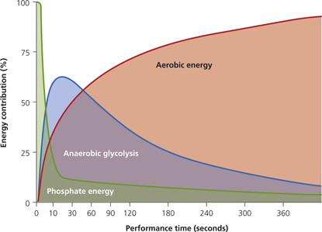

Topic 3 : Fuels (both chemical and food) required for resynthesis of ATP during physical activity and the utilisation of food for energy.

How do the following fuels resynthesize ATP? What are they stored as and where?

Phosphocreatine

Carbohydrates

Fats

Protein

Topic 4 : Oxygen uptake at rest, during exercise and recovery, including oxygen deficit, steady state, and excess post-exercise oxygen consumption
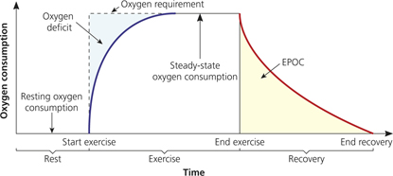

Topic 5 : The multi-factorial mechanisms (including fuel depletion, metabolic by-products and thermoregulation) associated with muscular fatigue as a result of varied exercise intensities and durations Passive and active recovery methods to assist in returning the body to pre-exercise levels.

What are the different types of fatigue?

Describe each of the recovery techniques and when they should be used?
Active recovery

Passive recovery

Replenishment of energy stores

Replenishment of fluids and electrolytes

Explain the multi-factorial mechanisms associated with fatigue during physical activity and sporting events resulting from the use of the three energy systems under varying conditions.
Compare and contrast suitable recovery strategies used to counteract fatigue and promote optimal performance levels.

