Nutritional strategies

 | Pre-Event (1-7 days before) | Pre-event (3-4 hours before event) | Pre Event  1 hour before | During Event | Post event
Short Duration (<60min)  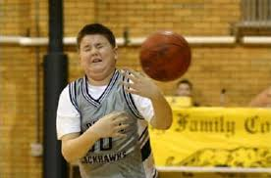Social Basketballer | Adequate glycogen consumption and normal balanced diet.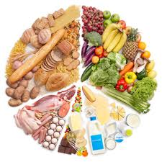 | Good Low GI meal 3 hours before event to stablise blood glucose or light snacks 1-2 hours before .  Wholemeal salad sanger 3 hours before.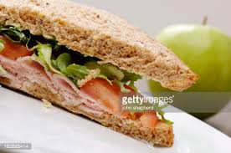 | Banana - High GI increased CHO availability  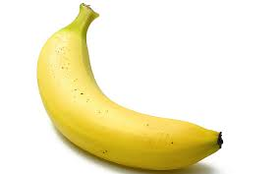 | No need for refuelling during event.  Fluid replenishment is required. Water is fine but sports drinks also good as they are more palatable.  Water  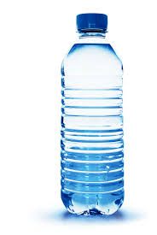 | Glycogen stores need to be replenished before next training/event. CHO and Protein together recommended.  Normal balanced diet
Moderate Intensity or intermittent sports  (60-90 min)  Netball or AFL player  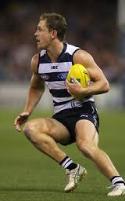 | Adequate glycogen consumption. Tapering of training in 24-36 hours before event.  Normal balanced diet + tapering  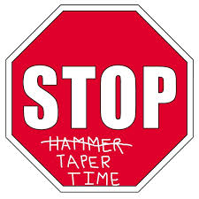 | Good Low GI meal 3 hours before event to stablise blood glucose or light snacks 1-2 hours before .  Wholemeal salad sanger 3 hours before. | light snacks 1-2 hours before . High G-I increases CHO availability. | No need for refuelling if CHO are adequate. Sports drinks recommended for rehydration for extra CHO content.  Sports Drink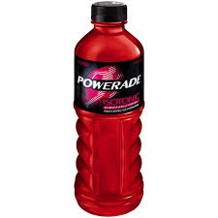 | Glycogen stores will have been mostly depleted.  High GI CHO should be ingested in first 30 min and 2 hours. Should combine CHO with protein.  Milkshake in post 30 min window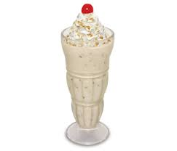
Prolonged sub-maximal event  Marathon Runner  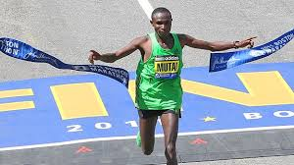 | Should be Carb loading. Tapering training for 2-4 days and consuming high CHO diet of 7-12g/kg body weight) | Good meal 1-4 hours before. Eat Low GI meal as it prolongs glycogen-reliance. |  | Refuelling using high GI food, CHO gels or sports drinks is recommended to help glycogen sparing.  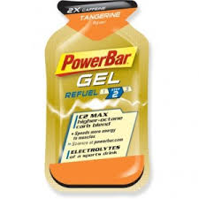 | Glycogen stores will have been depleted. High GI CHO should be ingested in forst 30min and 2 hours, Should combine CHO with protein.  Milkshake and sandwich

